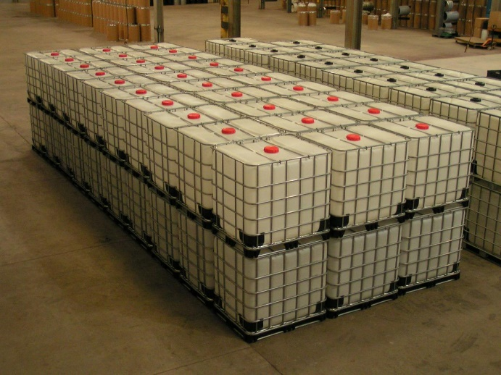
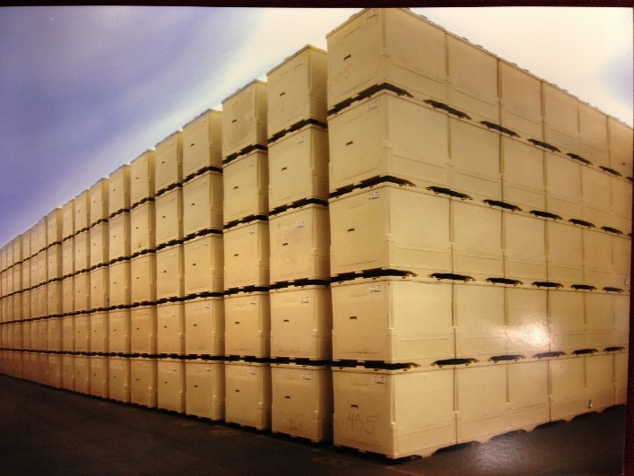
Meet the Caliber 315 Gallon Liquid IBC

Bottle & Cage VS. The Caliber

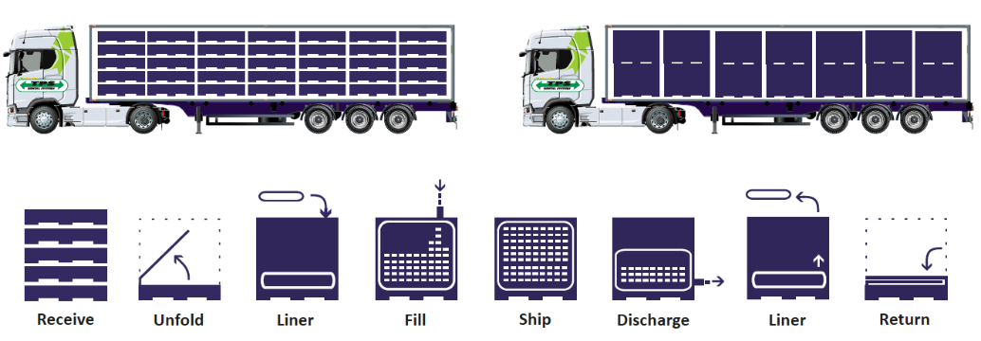
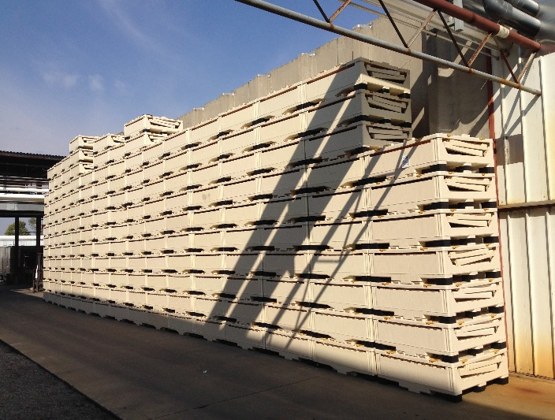
Opened 53’ truck = 168 containers Opened 53’ truck = 56 containers

Stackable
Collapsible
info@tripakinc.com
847.951.9025
TRIPAK, INC.

Caliber Outperforms conventional IBC’s

Up to 30% savings over bottle & cage
Minimize Contamination and Product Loss
Maximize ROI– Caliber stacks 5 High Lasts for 10+ years
Disposable Liners
Safer Employee Handling
Efficient Set up and Breakdown

